How to complete your Health Passport
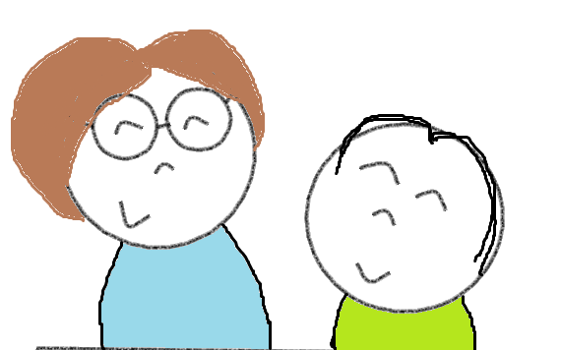
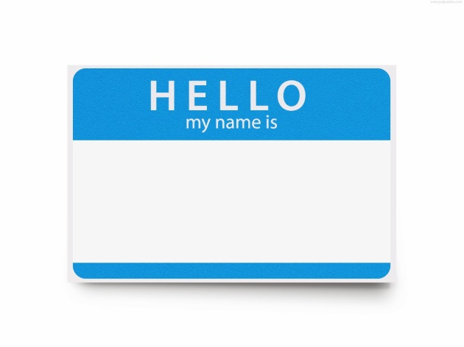
My Name is:
Please include your full name e.g. John McCarthy
I like to be called:
If you use a different name or a nickname e.g. Jack
My Parent/Guardian
Name:
The name of your legal guardian
Telephone Number:
A contact number for your legal guardian
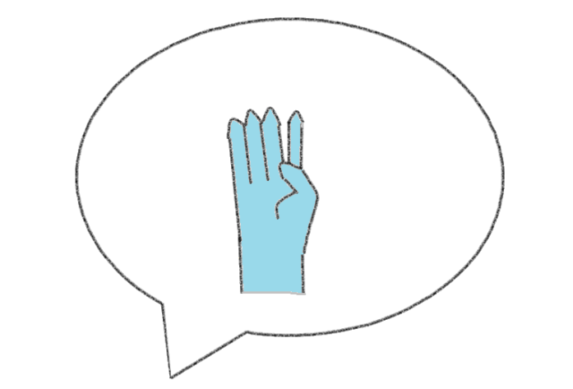

I communicate by
Here you might say
- I use sign language or Lámh.
- I only use a few words.
- I am non verbal.
- I communicate by speaking.
How best to communicate with me
Here you might say
- I do not like the word “magic” please do not use this word when speaking to me.
- Please speak slowly.
- Give me extra time when communicating with me.

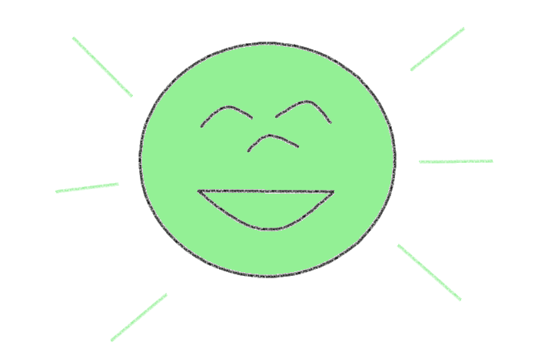
Things I like (what makes me happy, things I like to do, see or talk about)
Here you might say
- I love my pet dog Lucy.
- I like colouring.
- I like quiet spaces.
Things I do not like (what upsets me, things I do not like to do, see or talk about
Here you might say
- I do not like needles.
- I do not like loud noises.
- I do not like talking about school.
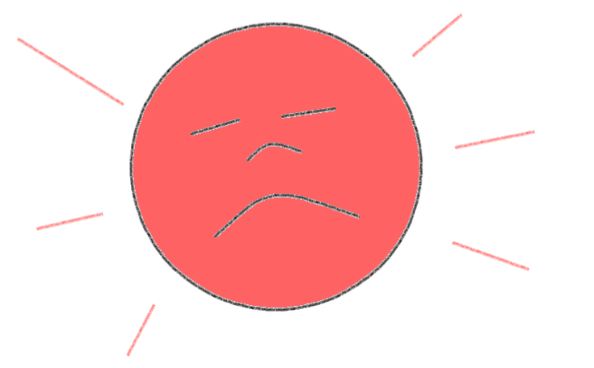
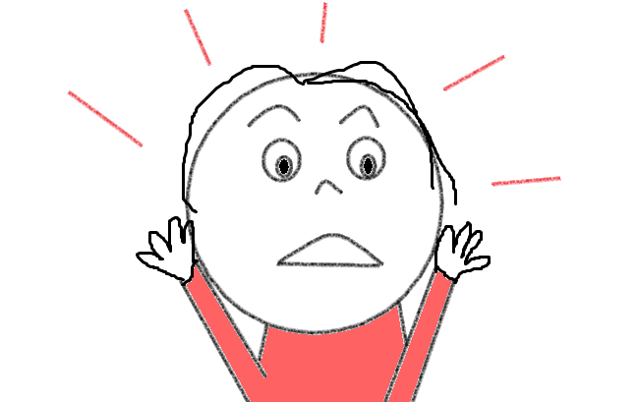
What I do if I am afraid or worried
Here you might say
- I cry if I am afraid
- I become very quiet

How you can support me if I am afraid or worried
Here you might say
- Talk to me about something I like
- Call my parent or guardian
- Reduce noise in the room

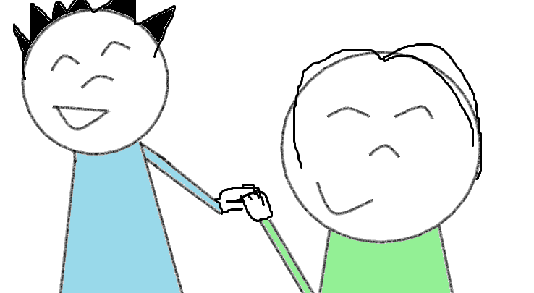

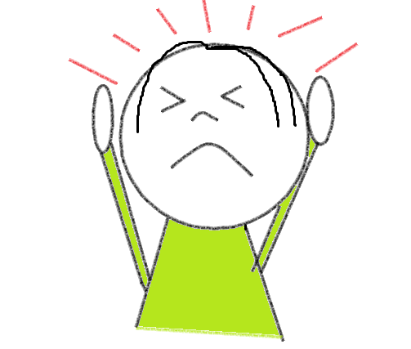
Things I do if I am sore or in pain
Here you might say
- I will tell you I have a headache
- I sometimes cry
- I will hold the place where I am sore

How best to gain my help when examining or caring for me
Here you might say
- Distract me by talking about something I like
- Show me what you are going to do on my teddy first
- Make sure my parent or guardian is there

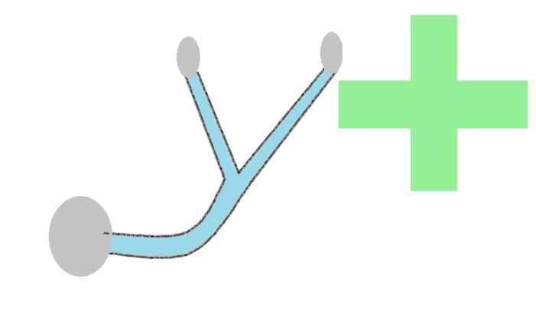
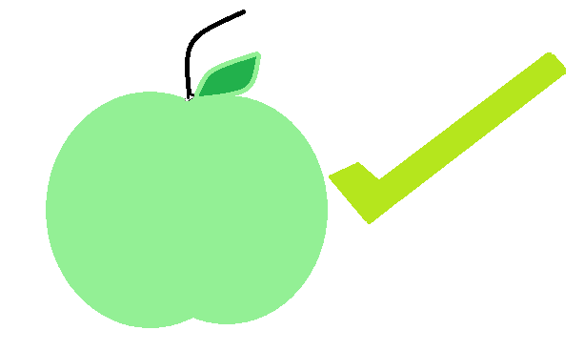
Foods I like
Here you might say
- I like carrots
- I like soft foods

Foods I do not like
Here you might say
- I do not like fish
- I do not like my food to touch
- I am a fussy eater

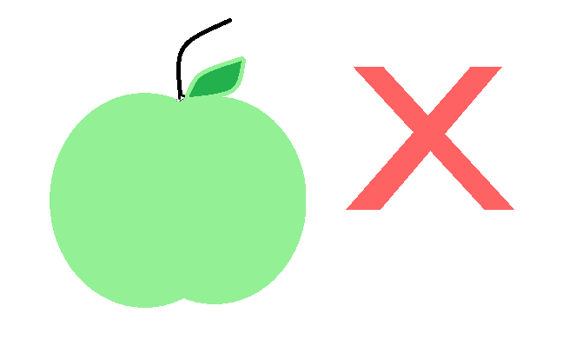


Help I need with eating
Here you might say
- I need a soft diet
- I am PEG fed
- I do not need any help when eating

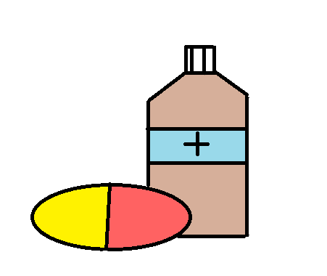

How I like to take medicine e.g. liquid/in food
Here you might say
- I do not like to take tablets

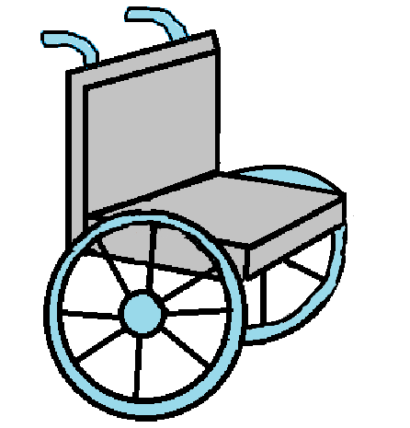
Help I need with moving
Here you might say
- I use a wheelchair
- I cannot walk
- I crawl
- I do not need any help with moving

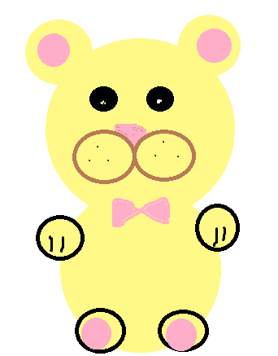

Items that make me feel calm (teddy, tablet, toy).
Here you might say
- My teddy
- Weighted blanket
- Ear defenders

Please bring this passport to hospital with you.
If you have something that helps you feel calm like a teddy or a toy/sensory item, please bring this to theatre with you.

Anything else you should know about me (anything else we can do to make your hospital visit easier for you)
Here you might say
- I need a quiet space to keep calm
- I do not like meeting too many new people

Carers/Parents/Guardians:
Has your child had a previous hospital visit?
(Circle Answer)
Yes No
If yes, please outline in detail what helped in reducing your child’s anxiety or what you think would have helped
Here you might say
- My child went to sleep using the mask last time and that worked very well.
- My child felt scared when they went into the theatre and saw lots of people. It would be better this time if they could not see all the staff members in the room.
- We found our room very noisy last time and this made my child feel distressed. A quiet space would work well for them.

Completed by: _____________John McCarthy___________
Relationship to Health Passport Owner:________Father_________
Date: _______01/11/2021_______

